2023/2024 Rugby Season – how to Register

This season all memberships are purchased in the RFU Game Management System (“GMS”)
This is a simple 2-step process:
- Register your child as a player (this was previously called affiliation) and
- Purchase their membership in the system.

Step 1 – Log into GMS:
If your child was previously a member you should already have a GMS account and your child(ren) will be linked to it. Click here to log in:
https://gms.rfu.com/GMS/Dashboard/Organisation/2571

If you are new to the M&Js or you need to set up an account, use the link below: https://help.rfu.com/support/solutions/articles/103000063984-how-do-i-create-an-account
BUT - make sure you choose Jersey RFC not Jersey Reds as your club.
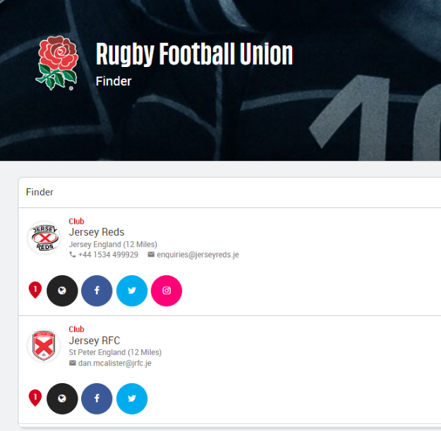

X

Once you are logged in you can register your child as a player
The green box on your GMS dashboard shows options for all children that are linked to your profile.
If your children are not showing on your profile use the Add button under the Family and Friends section. Make sure Jersey RFC is listed under “my organisations”, if it’s not, again there is an Add button. Be extra careful to choose Jersey RFC not Jersey Reds.
Click on “Register as player (age Grade) [child’s name]”
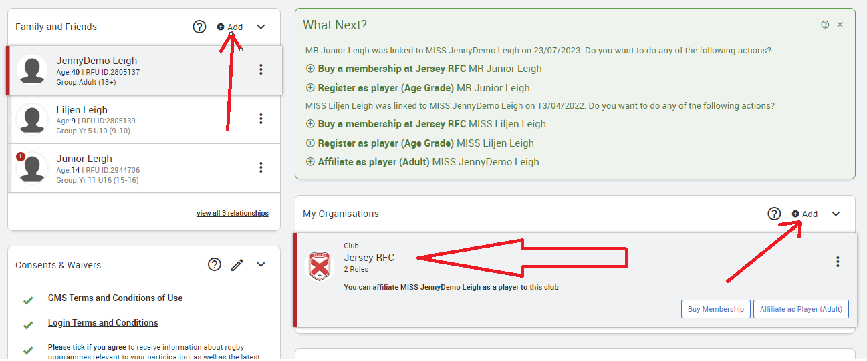

Complete all sections of the form (make sure you scroll down) before you submit/save (button top right)
Why is this important?
School Details
- we may group new players from the same school together to help them settle in
- sometimes we may need to make your child’s school aware of an injury sustained during rugby, to ensure that they get the correct aftercare and support.
Consent to photo distribution
- it’s great to celebrate players’ achievements across our social media channels and in the local press. However, we understand if parents would prefer us not to share their child’s image online, so we request your consent in advance
- if consent is not given, we will endeavour to ensure their image is not shared; this may include not taking part in team photos
- we do not use full names when referring to age grade players on social media
- contact our Safeguarding Officer Claire White safeguarding@jrfc.je if you have any concerns about photo distribution

Consent to Emergency Detail Distribution and Consent to Medical Distribution
- should your child sustain an injury we may need to share your contact details and your child’s medical details with the emergency services
Medical Details
- tell us about any allergies, medical condition or additional need which may affect your child's participation in rugby
Emergency contacts
- please make sure your details are up to date so we can reach you if we need to
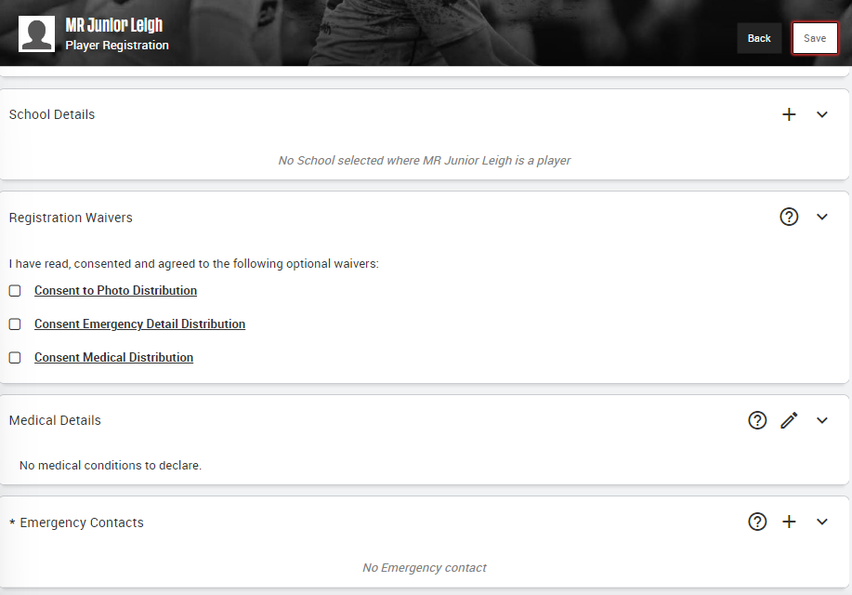

Step 2 – Purchase membership::
After you have registered your child(ren) as a player you are ready to purchase membership.
Your options will appear in the green box on your dashboard:
- For all players in U6s to U11s AND Junior Mixed Touch the membership fee is £100
- For all players in U12s to U18s (Colts) the membership fee is £140
If you are purchasing membership for more than one child, you will receive a sibling discount, which is applied at checkout.
The discount applies to the second and subsequent children and is set at £30 for U12-U18 players and £15 for U6-U11 and Junior Mixed Touch players.
Make sure you have selected the correct membership option according to your child’s age:
For players in U12s – U18s (Colts) inclusive choose from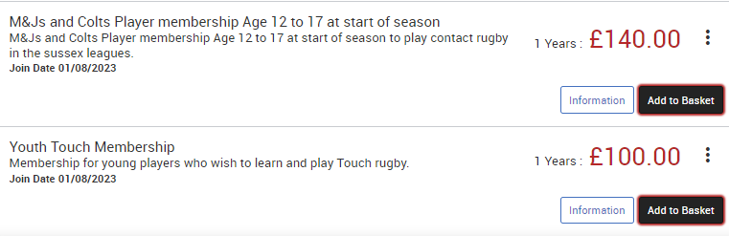
For players in U6s – U11s inclusive choose from 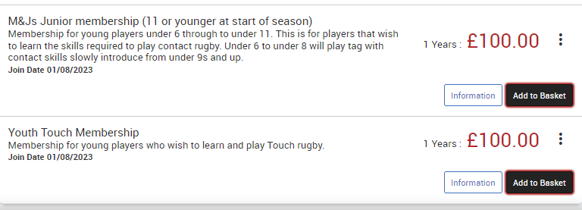

Still unsure? Jenny, our Membership Secretary can help.
jenny.leigh@jrfc.je

